Bulls Eye Maculopathy Highlighted With FAF
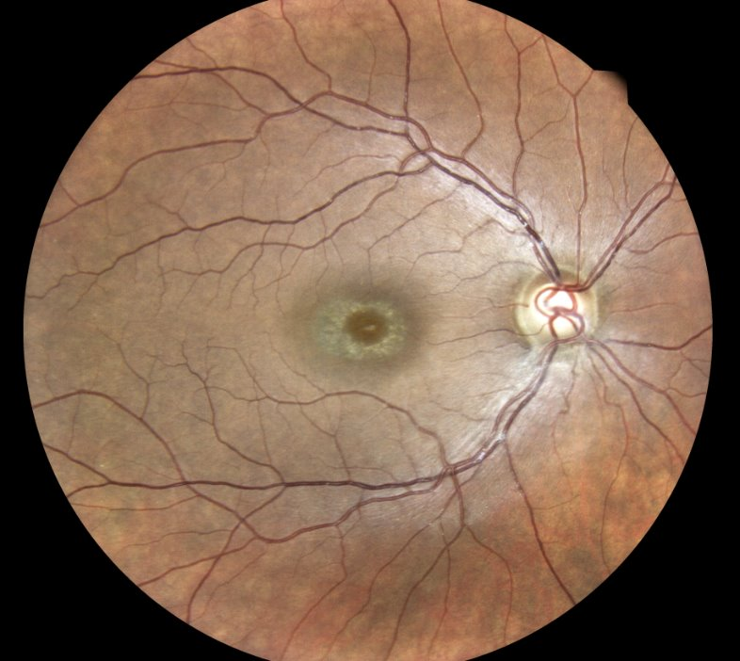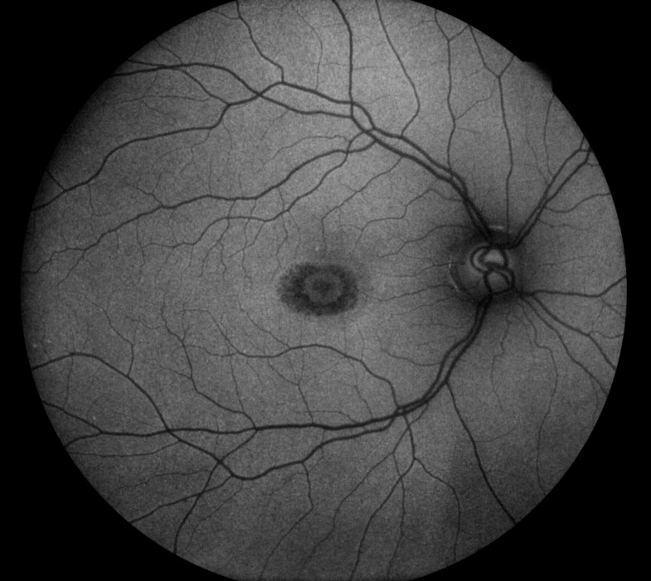

 Eidon AF UWF Images Courtesy of Julie Rodman OD, FAAO

